Doc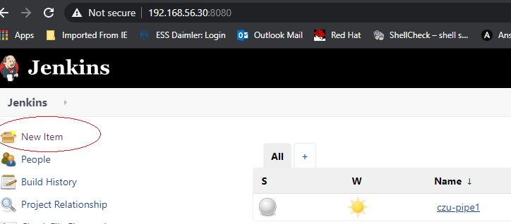

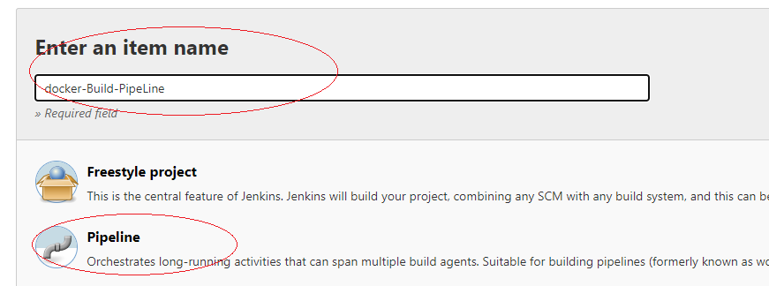

Now put all the files in github and here is my Jenkins file/path <https://github.com/czu002/pub/upload>

Please note, once uploaded the files to github, we must click on commit. Then get the code from the <https://github.com/czu002/pub.git> also git RPM must be installed in your Jenkins linux/windows server.

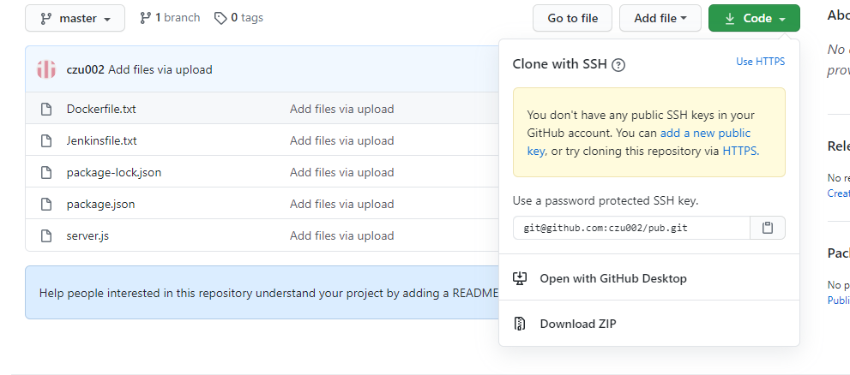

Now go to Jenkins and add the git URL in repository URL.

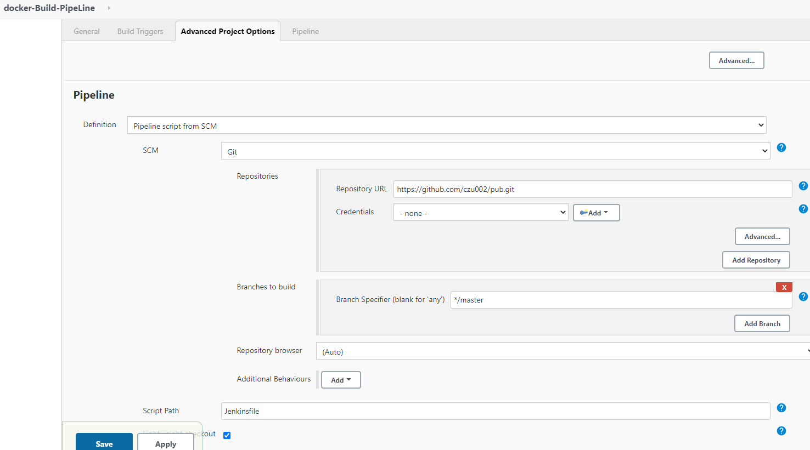

Now click on ‘build now’.

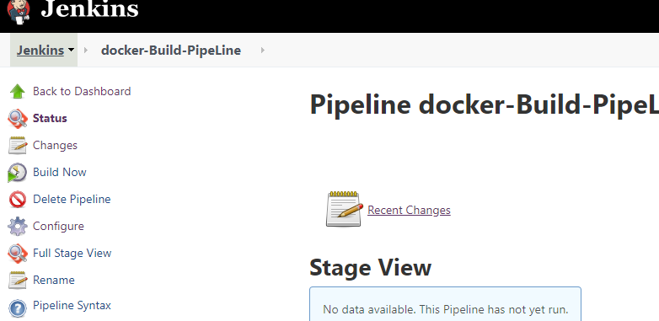

<https://www.youtube.com/watch?v=z32yzy4TrKM>